14th International course in Advanced Sinus surgery techniques 23rd – 25th October 2017, Amsterdam

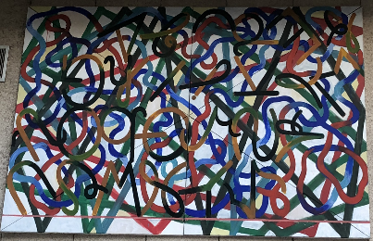
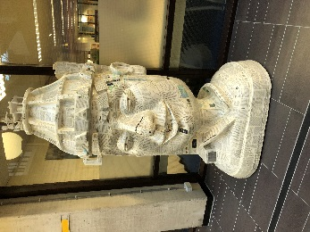
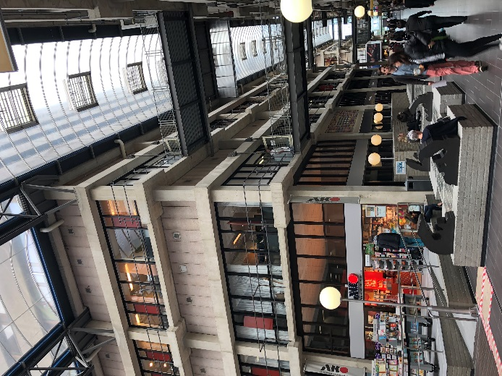
Thank you very much to the ERS for the award of a 2017 fellowship. I was delighted to complete this at the advanced sinus surgery course organised by Professor Fokkens. Amsterdam is an excellent city to visit and I learned a great deal in my time there.
The course was very well organised and a combination of instructional lectures, live surgery and cadaveric dissection with state of the art surgical equipment from Medtronic & Storz. The course faculty were all experts in the field of rhinology and anterior skull base surgery, very keen to discuss any area of rhinology and extremely approachable.
The format of the course was split into two days instructional sessions and one day of fresh frozen cadaveric dissection tuition. Academic Medical Centre (AMC – picture above) was the host for the course and is a fascinating venue and there was excellent catering throughout. AMC is a large very open plan building with great facilities for the course. Much of the open spaces are filled with modern art – I understand from one of the faculty at the time of building 1% of the cost was spent on artwork and for a time it housed one of the largest modern art collections in Amsterdam.
Day one consisted of talks on endoscopic anatomy from Prof Stammberger, sinonasal imaging & pre FESS surgical checklists, perioperative care, approaches to the sphenoid & frontal sinuses, medial maxillectomy, surgical epistaxis & CSF leak management and some challenging interactive cases.
The second day started with an instructional lecture on mucocele management followed by live surgery – a challenging inverted papilloma with multiple attachments in the ethmoid complex. The remainder of the day covered endoscopic DCR, inverted papilloma, juvenile nasal angiofibroma and finished with how to avoid and potentially manage complications in sinus & skull base surgery.
Day three was cadaveric dissection. We were paired up and provided with excellent endoscopic kit – the cadaveric specimens had all been imaged, there was tri-planar CT scans, a navigation system & technical support from the AMC staff and company representatives. A dissection manual was followed from sphenoidotomy & pituitary fossa exploration through to a Draf 3 procedure. At all stages there was expert tuition and guidance available from the faculty, who were very happy to talk us through any aspect of sinus or skull base surgery. Throughout the dissection day there were a number of demonstrations including ethmoidectomy & Draf 2a/2b from Prof Stammberger, Draf 3 from Prof Fokkens, an example of complications/’a bad FESS’ from Prof Kamel and so on. I found observing these sessions very helpful for my own dissection.
Overall I thought the course was excellent and I have brought home new knowledge and learnt new operative skills that will benefit me and ultimately my patients. For this I would like to say many thanks to the ERS and the course organisers! http://www.sinuscourse.nl
Stephen Ball
ENT Specialty Registrar/ST7 Northern Deanery
NIHR Academic Clinical Lecturer Newcastle University, UK.

